SIMATS ENGINEERING ASSESSMENT TOOL 2

COURSE NAME: COMPUTER NETWORKS COURSE CODE: CSA07

COURSE OUTCOME COVERED

CO4:
Design network topologies star, mesh, bus, and hybrid using networking devices, transmission media, and cabling standards
(BL2,BL6)
Assessment Tool Weightage: 30%

Annexure A

Industry Problem Solving Task

Code of Conduct:
I R.HARI KRISHNAN(192565075) (Name / Reg No) certify that this submission is my original work and that I have adhered to the guidelines specified for this assessment.
I understand that any violation of academic integrity rules will result in disciplinary action.

Signature of the student:
R.Hari krishnan
Annexure A

Industry Problem Solving Task

- A star topology is ideal for a 20-person startup because all devices connect to a central switch, making the network easy to manage and troubleshoot. At the core sits a Layer 2/Layer 3 managed switch (such as a Cisco Catalyst or Netgear ProSafe) with at least 24 ports to accommodate all workstations, printers, and VoIP phones with room to grow. Each device connects to the switch using Cat6 UTP cables, which support Gigabit speeds up to 100 meters — more than sufficient for any typical office floor plan. The switch uplinks to a router/firewall (such as a Cisco RV series or pfSense appliance) that handles internet access, DHCP, and network address translation. A Wi-Fi access point connected to the switch extends wireless coverage for laptops and mobile devices. The key advantage of this design is fault isolation: if one workstation's cable fails, only that single node goes offline, leaving all other 19 employees unaffected. Centralised cable management also simplifies future moves, adds, and changes.
That's a solid, accurate design write-up — the technical details check out: Cat6 UTP does support Gigabit speeds to 100m, a 24-port managed switch gives comfortable headroom over 20 users, and the fault-isolation point is the classic star-topology advantage. One thing worth adding if VoIP phones and the AP are in the mix: look for PoE (Power over Ethernet) on the switch, so those devices don't need separate power bricks.
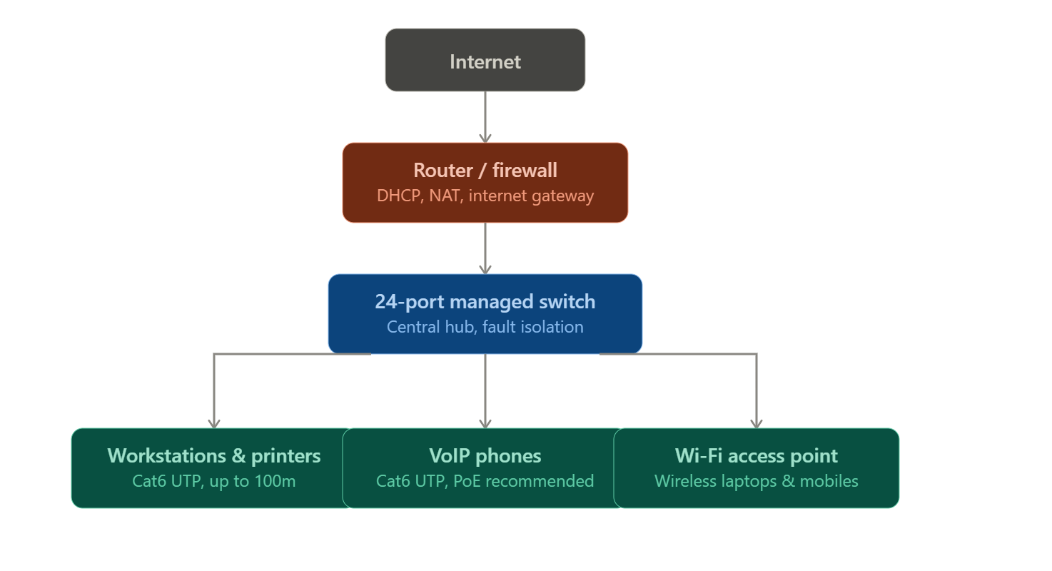
Here's the design as a diagram:
- A bank demands near-zero downtime, making a full or partial mesh topology the right choice. In a full mesh, every core network device — routers, core switches, and servers — connects directly to every other device, so no single link or node failure can bring down the network. For a bank, a partial mesh is typically deployed at the core layer (connecting all core switches and firewalls to each other) while the distribution and access layers use redundant uplinks to at least two core switches. Dual enterprise-grade routers (such as Cisco ASR or Juniper MX series) provide BGP-based redundant internet connectivity. All links between core devices use fiber optic cables — either single-mode for long distances between buildings or multi-mode OM4 within the data center — because fiber is immune to electromagnetic interference, supports very high bandwidth, and is essential for maintaining low-latency financial transactions. Redundant power supplies, UPS systems, and RAID storage arrays further complement the mesh design. The justification is straightforward: when a link fails in a mesh, traffic automatically reroutes through alternative paths in milliseconds using protocols like OSPF or BGP, satisfying regulatory requirements for uptime and data integrity.

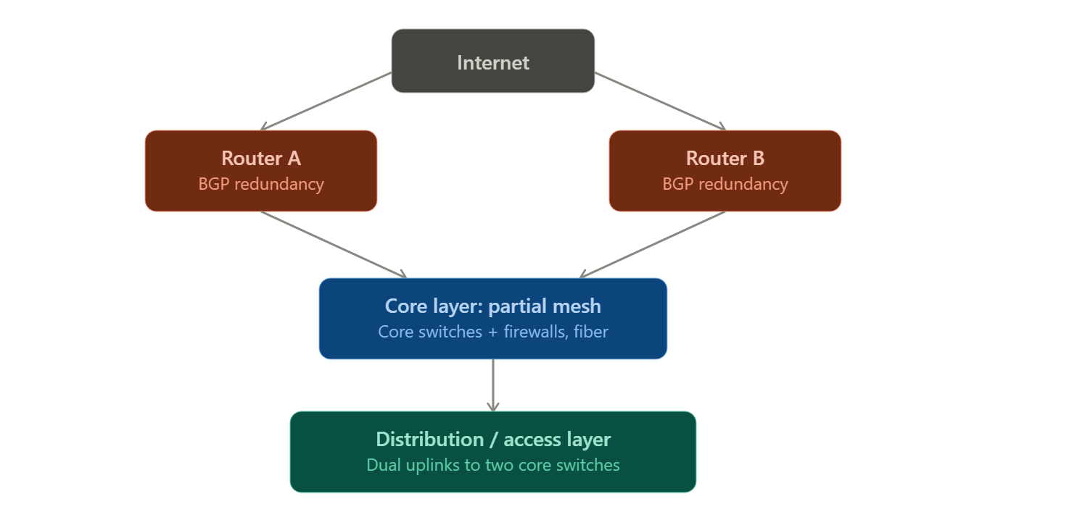
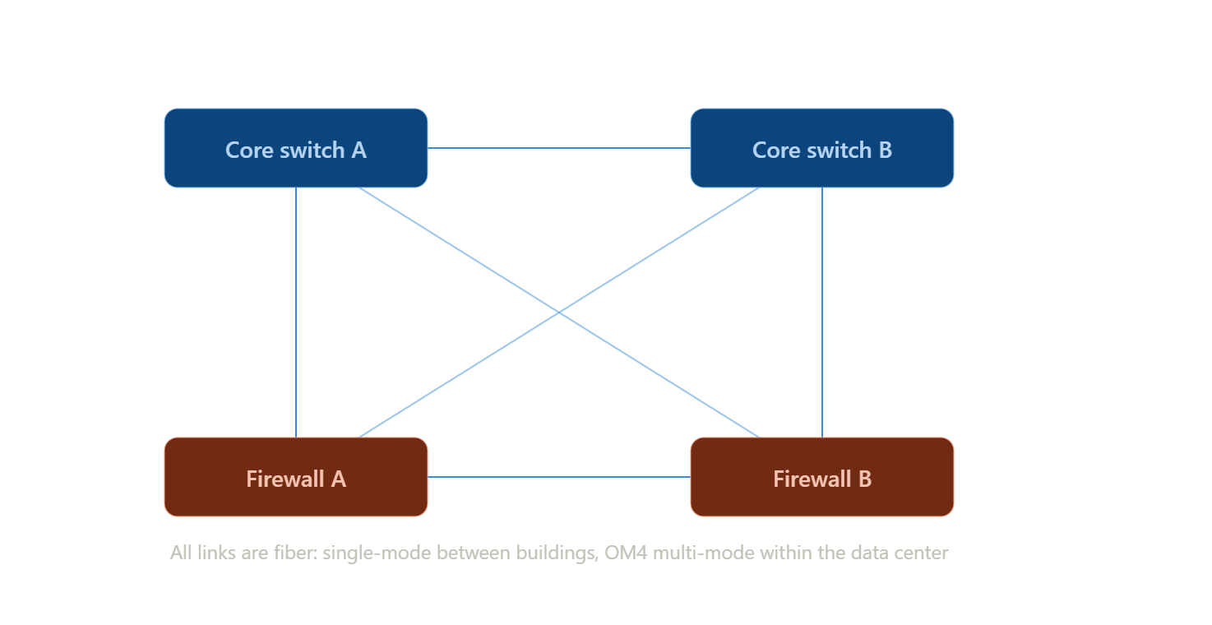
The core layer zoomed in, showing what "partial mesh" actually looks like — every core device wired directly to every other core device, so any single fiber link or node can fail without splitting the network.
- For a small classroom lab with a tight budget, bus topology offers the lowest hardware cost because all computers share a single common communication line — the bus — eliminating the need for a central switch or hub. A single coaxial cable (RG-58, 50-ohm) or, in a modern variation, a single Cat5e/Cat6 cable daisy-chained through an inexpensive unmanaged hub runs along the length of the room. Each computer connects to the backbone using a T-connector and a BNC connector in a classic coaxial setup, with terminators (50-ohm) placed at both ends of the cable to absorb signals and prevent reflection. For a more contemporary low-cost implementation, a single inexpensive 8- or 16-port unmanaged switch replaces the terminators and uses Cat5e UTP patch cables to each workstation — achieving bus-like simplicity at minimal cost. The primary limitation is that the network is susceptible to collisions and a single cable break disrupts all connected machines, but for a supervised classroom environment with light usage (internet browsing, file sharing), this trade-off is entirely acceptable. No dedicated server is required; a teacher's PC can share resources using built-in Windows/Linux file sharing.
Bus topology:

• Cabling: classic implementation uses coaxial cable (RG-58) with T-connectors and BNC connectors tapping into the line; both ends need a 50-ohm terminator to absorb the signal and prevent it reflecting back and causing interference.
• Advantages: cheapest topology to implement — minimal cabling, no central device required; easy to extend for small networks.
• Disadvantages: the entire network shares one collision domain, so as more devices are added, performance degrades from collisions; a single break anywhere in the backbone cable takes down the whole network; troubleshooting is hard because a fault could be anywhere along the line; largely obsolete today — replaced by star topologies using switches, which don't have these collision or single-cable-break problems.
• Best suited for: historically, very small, low-traffic networks with a tight budget. In practice today it's rarely deployed with real coaxial cable — most "bus-like" cost-saving setups actually use a cheap unmanaged switch instead.
- A large university campus serves thousands of users across multiple buildings — lecture halls, labs, libraries, dormitories, and administration — making a single topology inadequate. A hybrid topology combines the best elements of multiple designs: a fiber-based ring or mesh at the campus backbone level for redundancy, a star topology within each building for manageability, and bus or tree structures within individual labs for cost-efficiency. At the campus core, high-speed fiber optic cables (single-mode, 10 Gbps or 40 Gbps) interconnect core routers and multilayer switches using a ring or partial mesh arrangement, ensuring that no single link failure isolates an entire building. Each building has its own distribution switch connected to the campus core via dual fiber uplinks. Within each building, a traditional star topology branches from the distribution switch to floor-level access switches, which then connect individual devices via Cat6 cables. This hierarchical three-layer model — core, distribution, and access — is the industry standard for enterprise and campus networks because adding a new building simply means installing a new distribution switch and running fiber to the core, with no disruption to existing infrastructure. Wireless access points throughout the campus connect via PoE (Power over Ethernet) to access switches, eliminating the need for separate power cabling. The hybrid design thus delivers redundancy at the backbone, simplicity at the building level, and scalability campus-wide.
Hybrid topology & the three-layer hierarchical model:
It is a network built by combining two or more topology types, using each one where its strengths matter most rather than forcing a single design across an entire organization. Large networks almost always end up hybrid in practice — pure star, mesh, or bus designs don't scale cleanly across thousands of users and multiple buildings.
The three-layer hierarchical model (also called the Cisco hierarchical network design) is the standard way large campus and enterprise networks are structured:

  - Core layer: the high-speed backbone. Connects distribution layers together and, at a campus, connects buildings to each other. Optimized purely for fast switching/routing
— minimal filtering or policy logic here, since any delay at this layer affects the whole network. Typically a ring or partial mesh of core routers/switches for redundancy.
  - Distribution layer: the aggregation point between core and access. Applies routing, filtering, QoS, and access policies. Each building (or major zone) usually has its own distribution switch, connected to the core with redundant (dual) uplinks so a single link failure doesn't cut the building off.
  - Access layer: where end devices actually connect — workstations, printers, phones, access points. Typically star topology from floor-level access switches, since this layer needs to be simple, cheap per-port, and easy for non-network-specialist staff to manage or extend.

Why hierarchy instead of one flat design:

  - Redundancy where it matters most — a link failure at the core (affecting potentially the whole campus) is far more costly than a link failure at the access layer (affecting one desk), so redundancy budget is concentrated at the core/distribution layers via mesh/ring and dual uplinks.
  - Scalability — adding a new building means adding one distribution switch and one fiber run to the core; existing buildings are untouched. A flat design (e.g., one giant star or mesh across the whole campus) doesn't scale this cleanly.
  - Fault containment — a failure or broadcast storm at the access layer in one lab doesn't propagate to the whole campus, because the distribution layer boundaries contain it.
  - Fiber vs copper split — fiber (single-mode for long inter-building runs) is used at core/distribution because of distance (Cat6 is capped at ~100m) and bandwidth needs (10/40 Gbps+); copper (Cat6 UTP) is used at the access layer because runs are short (within a floor) and it's cheaper per port.

- Designing a network for a company with multiple departments involves creating a structured and scalable architecture using switches and routers to ensure efficient communication and security. Each department (such as HR, Finance, Sales, and IT) is connected through dedicated Layer 2 switches that form the access layer, allowing devices like computers and printers to communicate within the same department. These switches are then connected to a central Layer 3 switch or router, which acts as the core layer and enables communication between different departments through inter-VLAN routing. Virtual LANs (VLANs) are configured to logically separate each department’s network, improving security and reducing broadcast traffic. A router is also used to connect the internal network to external networks such as the internet, often with firewall functionality for security. Redundant links and backup paths can be included to ensure reliability, while proper IP addressing and subnetting are applied for efficient network management. This hierarchical design improves performance, enhances security, and allows easy expansion as the company grows.

VLANs & inter-VLAN routing: theory
The problem this design solves: if every department (HR, Finance, Sales, IT) sits on one flat physical network, they all share one broadcast domain — broadcast traffic (ARP requests, DHCP discovery, etc.) from any device reaches every other device on the network, which hurts performance as the company grows, and any device can potentially see traffic from any other department, which is a security risk (e.g., Sales seeing Finance's traffic).
VLAN (Virtual LAN): a way to logically partition a single physical switch (or set of switches) into multiple separate broadcast domains, without needing separate physical switches per department. Each port on a switch is assigned to a VLAN (e.g., VLAN 10 = HR, VLAN 20 = Finance). Devices in the same VLAN can communicate directly at Layer 2; devices in different VLANs cannot, even if plugged into the same physical switch, until something routes between them.

  - Access ports carry traffic for a single VLAN — used for the ports connecting end devices (a PC, a printer).
  - Trunk ports carry traffic for multiple VLANs over one physical link (tagged with 802.1Q) — used for links between switches, or between a switch and a router, so one cable can carry all departments' VLAN traffic.

Inter-VLAN routing: because VLANs are separate Layer 2 broadcast domains, a Layer 3 device is needed to route traffic between them (e.g., HR talking to a shared file server on Finance's VLAN). Two common ways to do this:

  - Router-on-a-stick: a single router interface, configured with sub-interfaces (one per VLAN), connects via a trunk link to the switch. Cheaper, but the router interface becomes a bandwidth bottleneck.
  - Layer 3 switch with SVIs (Switched Virtual Interfaces): the core switch itself has routing capability and a virtual interface per VLAN, routing between departments internally at wire speed. This is the modern standard for anything beyond a very small deployment, since it avoids the router-on-a-stick bottleneck.

Layer 2 vs Layer 3 switch:

  - Layer 2 switch: forwards frames based on MAC address within a single VLAN/broadcast domain only. Used at the access layer.
  - Layer 3 switch: can do everything a Layer 2 switch does, plus route between VLANs/subnets using IP, at hardware speed. Used at the core/distribution layer in this design.

Subnetting alongside VLANs: each VLAN is normally mapped to its own IP subnet (e.g., VLAN 10/HR = 192.168.10.0/24, VLAN 20/Finance = 192.168.20.0/24). This keeps
addressing organized per department and lets the router/Layer 3 switch apply access control lists (ACLs) between subnets — e.g., blocking Sales from reaching Finance's servers entirely, not just separating broadcast traffic.

RUBRICS FOR CALCULATION

Criteria | Weightage | Exemplary (4) | Proficient (3) | Developing (2) | Beginning (1)
Problem Analysis | 15% | Clearly identifies and deeply analyzes the industry problem with all factors | Good understanding with minor gaps | Basic understanding; some key aspects missing | Poor or incorrect understanding of the problem
Solution Design | 20% | Innovative, practical, and industry-relevant solution | Effective solution with minor limitations | Partially suitable solution | Inappropriate or unclear solution
Technical Implementation | 20% | Fully functional, accurate, and well-executed implementation | Mostly functional with minor errors | Partially implemented solution | Incomplete or non-functional implementation
Use of Tools & Technologies | 10% | Appropriate and advanced use of relevant tools and technologies | Correct use of tools | Limited or basic use of tools | Incorrect or no use of tools
Problem-Solving Approach | 10% | Logical, systematic, and well-structured approach | Mostly logical approach | Somewhat disorganized approach | No clear approach
Innovation & Creativity | 10% | Highly creative and original solution | Some creativity | Limited originality | No creativity

Criteria | Weightage | Exemplary (4) | Proficient (3) | Developing (2) | Beginning (1)
Testing & Validation | 5% | Thorough testing with real-world scenarios | Adequate testing | Minimal testing | No testing
Documentation & Presentation | 5% | Clear, professional, and  well-documented | Good documentation | Basic documentation | Poor or no documentation
Teamwork / Collaboration | 5% | Excellent coordination and contribution (if team-based) | Good collaboration | Limited participation | No collaboration or contribution

